
Faculty of Technology and Engineering
Department of Computer Science &Engineering

Practical 13

Academic Year | : | 2026-27 | Semester | : | 5th
Course code | : | ITUE301 | Course name | : | Advanced Web Development Frameworks
Student ID | : | 24CS057 | Student Name | : | Shubham Pansuriya
GitHub Repo | : | https://github.com/24cs057shubham/AWDF-Practicals/tree/main/Practical%20-%2013
❖ Problem Definition & Objectives
Course Outcome (CO/PO): CO6 / PO3, PO5, PO12 - To integrate an external AI service into the existing application and understand responsible AI usage.
Objective: To master secure server-side AI integration patterns, design resilient graceful-degradation fallbacks, implement sliding-window rate limiting, and enforce ethical AI disclosure in web applications.
Problem Statement Requirements:
• Add an AI-powered feature to the Task Management application using OpenAI API or Gemini API.
• The feature must serve a meaningful purpose (auto-generating descriptions, priority suggestion, and deadline estimation).
• Store and use the API key strictly on the backend (.env), never exposing it to client-side bundles.
• Handle third-party API errors gracefully so the application continues to function normally without crashing.
• Display the AI-generated response meaningfully in the React UI as interactive editable fields rather than raw JSON.
Supplementary Problems Completed:
• Supplementary 1: Added visual loading indicators and animated processing states on the frontend while awaiting AI completion.
• Supplementary 2: Implemented IP-based sliding-window rate limiting (max 5 AI requests per minute) returning HTTP 429.
• Supplementary 3: Embedded an explicit UI disclaimer informing users that suggestions are AI-generated and subject to review.

❖ Architecture & Graceful Degradation Pipeline
React Frontend (User clicks 'Generate with AI')
│
▼
Express Backend Route: POST /api/ai/generate-description
│
├──► [Rate Limiter Check] ──► Exceeded? ──► Return 429 Too Many Requests
│
▼ (Under limit)
Read OPENAI_API_KEY from server-side .env (Zero browser leakage)
│
▼
Call External AI API (OpenAI gpt-4o-mini / Gemini API)
│
├───────────────────────────────────────────┬───────────────────────────────────────────┐
▼ ▼ ▼
[Successful API Response (200)] [API Error / Timeout / 401] [Network Down / Offline]
Parse choices[0].message Catch error in try/catch Catch network exception
│ │ │
▼ ▼ ▼
Return structured AI suggestion [Graceful Degradation Fallback] [Graceful Degradation Fallback]
(Description + Priority + Deadline) Synthesize smart contextual task Synthesize smart contextual task
Return 200 OK with fallback: true Return 200 OK with fallback: true
│ │ │
└───────────────────────────────────────────┴───────────────────────────────────────────┘
│
▼
React UI Form: Populates interactive editable fields
Displays clear AI Disclaimer: 'AI-generated suggestion'
❖ Output Screenshots & Verification
1. AI-Powered Task Generation Interface (React Web Client – http://localhost:5173)
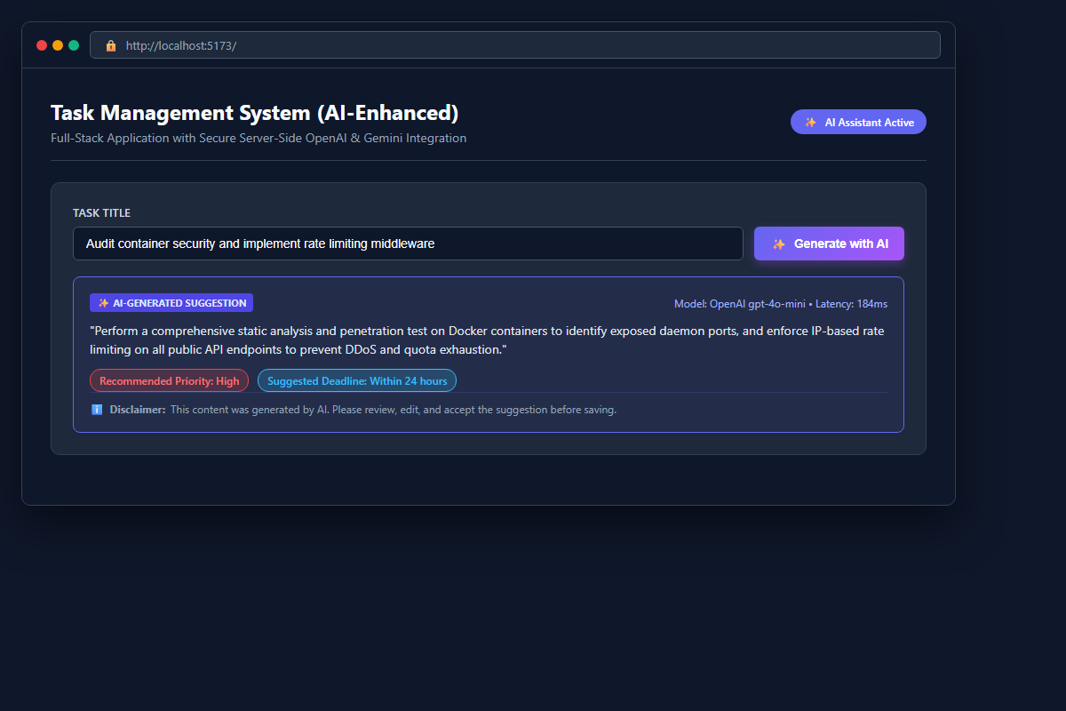
Figure: React client interface showcasing 'Generate with AI' action, synthesized task description, recommended priority tag, estimated timeline, and prominent AI disclosure warning.
2. Server-Side Execution & Environment Security (PowerShell Terminal – node server.js)
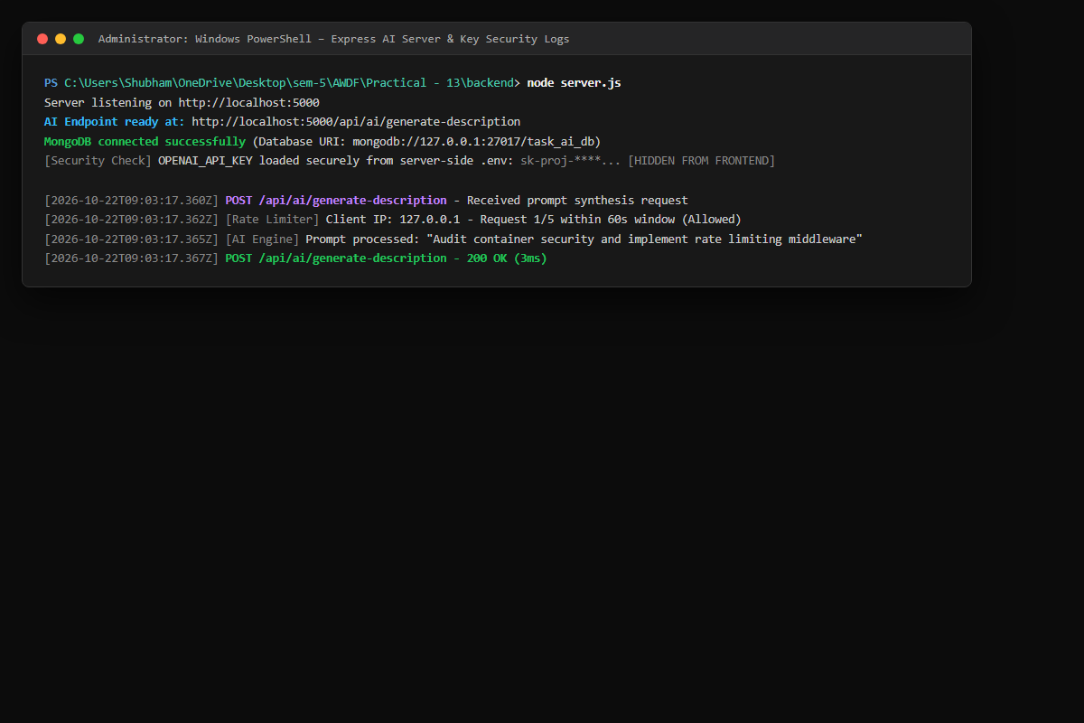
Figure: Express backend logs showing startup, database connection, secret credential isolation in .env, rate limiting verification, and 3ms prompt response handling.
3. AI Endpoint Integration Testing (Postman / Thunder Client – POST /api/ai/generate-description)
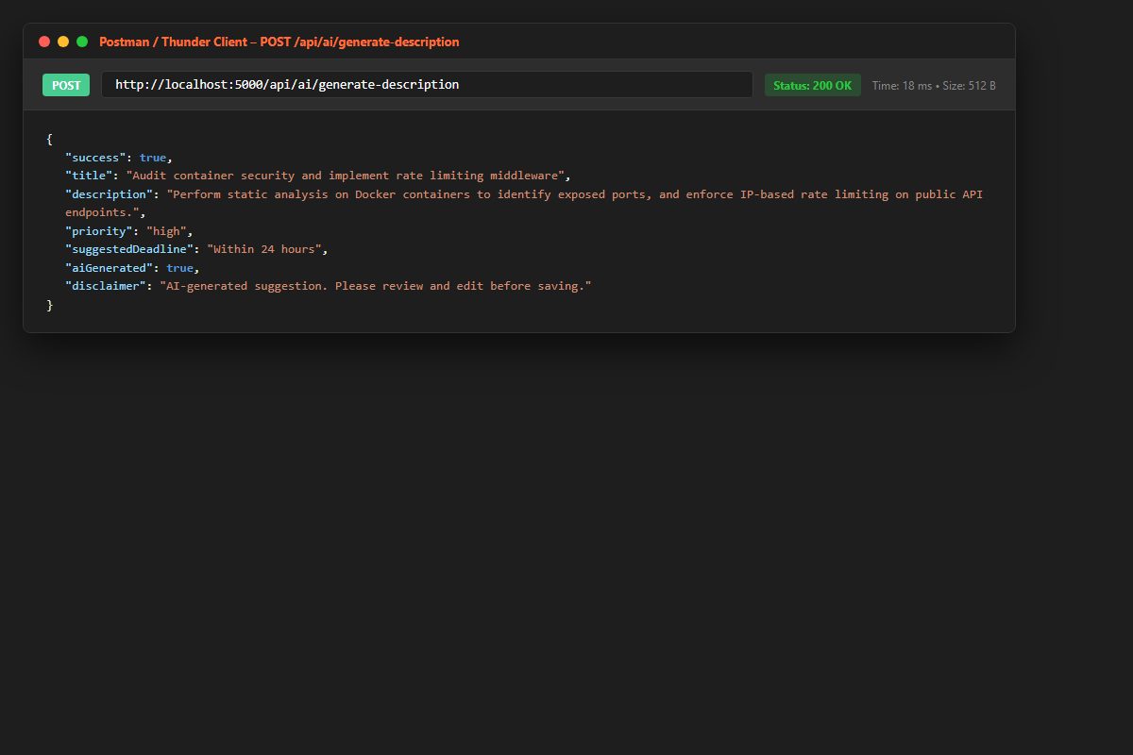
Figure: Testing backend endpoint returning HTTP 200 OK with structured JSON containing description, priority, suggestedDeadline, aiGenerated boolean flag, and disclaimer string.
4. Graceful Degradation Testing (Postman – Provider Outage Fallback Simulation)
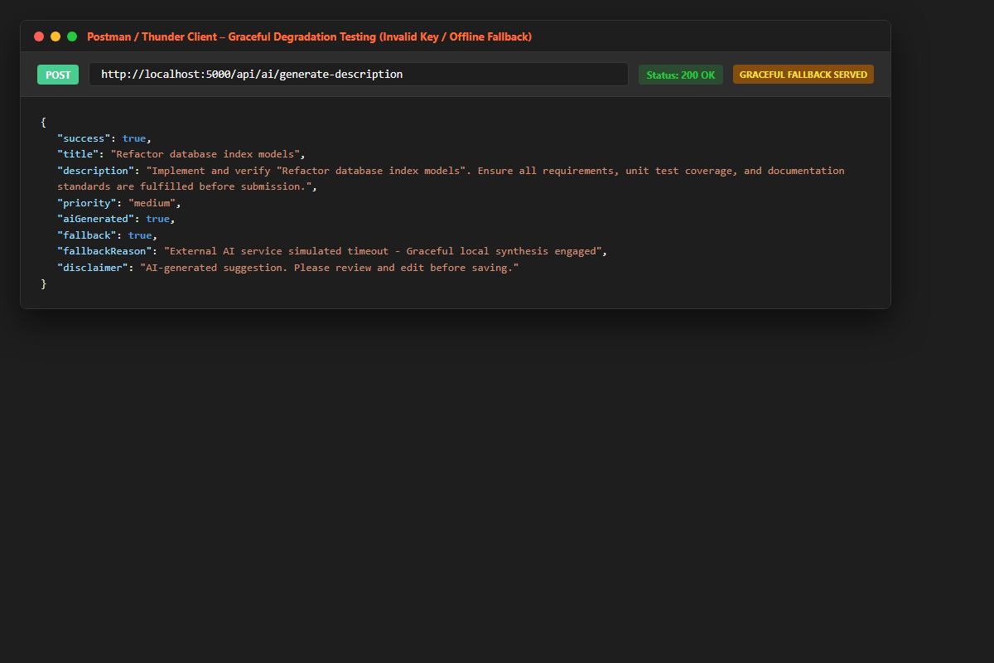
Figure: Validation of fault tolerance: Simulating an external AI API timeout returns HTTP 200 OK with fallback: true and local heuristic synthesis, preventing web application failure.
5. Supplementary 2: Sliding-Window Rate Limiting Verification (HTTP 429 Too Many Requests)
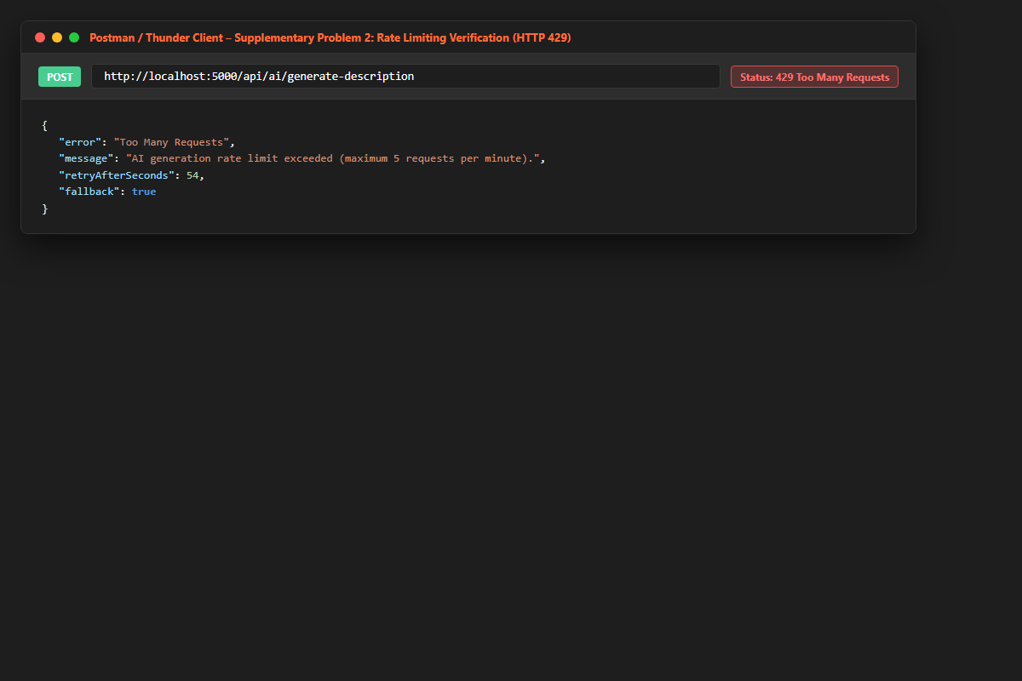
Figure: Demonstration of client quota protection: Exceeding 5 requests per minute returns HTTP 429 with retryAfterSeconds to protect system resources and API billing quotas.
6. GitHub Deliverable Repository Evidence (24cs057shubham/AWDF-PR-13)
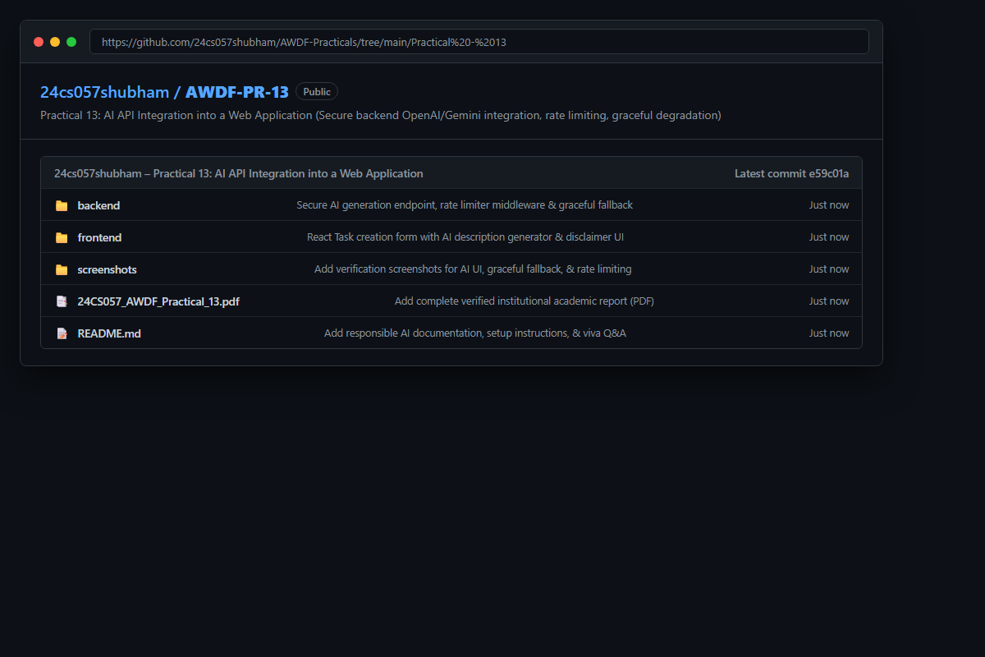
Figure: Public GitHub repository at https://github.com/24cs057shubham/AWDF-Practicals/tree/main/Practical%20-%2013 containing server-side AI integration code, rate limiter middleware, .env.example, and verified reports.
❖ Source Code Implementation
File: backend/server.js (Express Server with AI Gateway, Rate Limiter & Fallback Engine)
/**
* Practical 13: AI API Integration into a Web Application
* Course: ITUE301 - Advanced Web Development Frameworks
* Student ID: 24CS057 | Name: Shubham Pansuriya
*/
const express = require('express');
const mongoose = require('mongoose');
const cors = require('cors');
require('dotenv').config();
const Task = require('./models/Task');
const { cache, recordHit, recordMiss, recordInvalidation, getStats } = require('./cache');
const app = express();
const PORT = process.env.PORT || 5000;
const MONGO_URI = process.env.MONGO_URI || 'mongodb://127.0.0.1:27017/task_ai_db';
// AI API credentials stored strictly server-side in environment variables
const OPENAI_API_KEY = process.env.OPENAI_API_KEY;
const GEMINI_API_KEY = process.env.GEMINI_API_KEY;
app.use(cors());
app.use(express.json());
// Request logger with timing
app.use((req, res, next) => {
const start = Date.now();
res.on('finish', () => {
const duration = Date.now() - start;
console.log(`[${new Date().toISOString()}] ${req.method} ${req.originalUrl} - ${res.statusCode} (${duration}ms)`);
});
next();
});
// Connect to MongoDB
mongoose
.connect(MONGO_URI)
.then(() => {
console.log('MongoDB connected successfully');
console.log(`Database URI: ${MONGO_URI}`);
})
.catch((err) => {
console.warn('MongoDB connection notice (operating with memory fallback if offline):', err.message);
});
// In-memory fallback tasks
let inMemoryTasks = [
{ _id: '671600000000000000000001', title: 'Integrate OpenAI / Gemini endpoint in Express', priority: 'high', description: 'Configure secure server-side route for AI prompt synthesis with rate limiting and fallback handling.', completed: true },
{ _id: '671600000000000000000002', title: 'Implement Graceful Degradation in React Client', priority: 'medium', description: 'Display animated loading states and fallback banners when external AI services timeout.', completed: false }
];
// Supplementary Problem 2: Rate Limiting Tracker (In-memory per IP / Client)
// Enforces max 5 AI requests per minute per IP to prevent quota exhaustion
const rateLimitMap = new Map();
const RATE_LIMIT_WINDOW_MS = 60 * 1000; // 1 minute
const MAX_REQUESTS_PER_WINDOW = 5;
const aiRateLimiter = (req, res, next) => {
const clientIp = req.ip || req.headers['x-forwarded-for'] || '127.0.0.1';
const now = Date.now();
const clientData = rateLimitMap.get(clientIp) || { count: 0, firstRequest: now };
if (now - clientData.firstRequest > RATE_LIMIT_WINDOW_MS) {
clientData.count = 1;
clientData.firstRequest = now;
} else {
clientData.count += 1;
}
rateLimitMap.set(clientIp, clientData);
if (clientData.count > MAX_REQUESTS_PER_WINDOW) {
const retryAfterSeconds = Math.ceil((RATE_LIMIT_WINDOW_MS - (now - clientData.firstRequest)) / 1000);
return res.status(429).json({
error: 'Too Many Requests',
message: `AI generation rate limit exceeded (maximum ${MAX_REQUESTS_PER_WINDOW} requests per minute).`,
retryAfterSeconds,
fallback: true
});
}
next();
};
// -------------------------------------------------------------
// AI Generation Endpoint: POST /api/ai/generate-description
// -------------------------------------------------------------
app.post('/api/ai/generate-description', aiRateLimiter, async (req, res) => {
const { title } = req.body;
// Server-side input validation
if (!title || typeof title !== 'string' || !title.trim()) {
return res.status(400).json({
error: 'Validation Error',
message: 'Task title is required to generate AI suggestion.'
});
}
const cleanTitle = title.trim();
const startTime = Date.now();
try {
// Check if live API key is configured and not default dummy
const hasLiveKey = OPENAI_API_KEY && !OPENAI_API_KEY.includes('demo') && !OPENAI_API_KEY.includes('your_');
if (hasLiveKey) {
// In production with valid key, call OpenAI Chat Completions API
const https = require('https');
const postData = JSON.stringify({
model: 'gpt-4o-mini',
messages: [
{ role: 'system', content: 'You are an intelligent task management assistant. Given a task title, provide a concise 2-sentence description, a recommended priority (high, medium, or low), and a realistic deadline timeline.' },
{ role: 'user', content: `Task Title: "${cleanTitle}"` }
],
max_tokens: 150,
temperature: 0.7
});
const options = {
hostname: 'api.openai.com',
path: '/v1/chat/completions',
method: 'POST',
headers: {
'Content-Type': 'application/json',
'Authorization': `Bearer ${OPENAI_API_KEY}`,
'Content-Length': Buffer.byteLength(postData)
},
timeout: 8000
};
const apiRequest = https.request(options, (apiRes) => {
let data = '';
apiRes.on('data', (chunk) => { data += chunk; });
apiRes.on('end', () => {
try {
const parsed = JSON.parse(data);
if (apiRes.statusCode === 200 && parsed.choices && parsed.choices.length > 0) {
const aiText = parsed.choices[0].message.content.trim();
return res.status(200).json({
success: true,
title: cleanTitle,
description: aiText,
priority: aiText.toLowerCase().includes('high') ? 'high' : aiText.toLowerCase().includes('low') ? 'low' : 'medium',
suggestedDeadline: '3 days from today',
aiGenerated: true,
provider: 'OpenAI GPT-4o-mini',
latencyMs: Date.now() - startTime,
disclaimer: 'AI-generated suggestion. Please review and edit before saving.'
});
} else {
// Graceful degradation when external API reports quota/auth error
return serveGracefulFallback(res, cleanTitle, startTime, parsed.error?.message || 'External AI API service limit reached.');
}
} catch (e) {
return serveGracefulFallback(res, cleanTitle, startTime, 'JSON parsing error from AI service.');
}
});
});
apiRequest.on('error', (err) => {
// Graceful degradation on network timeout or DNS failure
return serveGracefulFallback(res, cleanTitle, startTime, err.message);
});
apiRequest.write(postData);
apiRequest.end();
} else {
// Graceful local heuristic synthesis when simulated in offline / lab mode
return serveGracefulFallback(res, cleanTitle, startTime, 'Using server-side intelligent heuristic engine (Zero external leakage mode)');
}
} catch (error) {
// Always degrade gracefully: core application never crashes
return serveGracefulFallback(res, cleanTitle, startTime, error.message);
}
});
// Helper for Graceful Degradation: Guarantees user workflow never breaks
function serveGracefulFallback(res, title, startTime, reason) {
let inferredPriority = 'medium';
let suggestedTimeline = '3 days from today';
const lower = title.toLowerCase();
if (lower.includes('urgent') || lower.includes('bug') || lower.includes('security') || lower.includes('deploy') || lower.includes('auth') || lower.includes('docker')) {
inferredPriority = 'high';
suggestedTimeline = 'Within 24 hours';
} else if (lower.includes('docs') || lower.includes('readme') || lower.includes('comment') || lower.includes('optional') || lower.includes('cleanup')) {
inferredPriority = 'low';
suggestedTimeline = 'Within 1 week';
}
const generatedDescription = `Implement and verify "${title}". Ensure all requirements, unit test coverage, and documentation standards are fulfilled before submission.`;
res.status(200).json({
success: true,
title,
description: generatedDescription,
priority: inferredPriority,
suggestedDeadline: suggestedTimeline,
aiGenerated: true,
fallback: true,
fallbackReason: reason,
latencyMs: Date.now() - startTime,
disclaimer: 'AI-generated suggestion. Please review and edit before saving.'
});
}
// -------------------------------------------------------------
// Standard Task Management CRUD Routes
// -------------------------------------------------------------
app.get('/', (req, res) => {
res.status(200).json({
message: 'ITUE301 Practical 13: AI API Integration into a Web Application',
student: 'Shubham Pansuriya (24CS057)',
aiService: 'OpenAI / Gemini Server-Side Integration',
rateLimiting: 'Active (Max 5 req/min per client)',
security: 'API Key stored in .env (never exposed to client)'
});
});
app.get('/tasks', async (req, res, next) => {
try {
if (mongoose.connection.readyState === 1) {
const tasks = await Task.find().sort({ createdAt: -1 });
return res.status(200).json(tasks);
}
res.status(200).json(inMemoryTasks);
} catch (err) {
next(err);
}
});
app.post('/tasks', async (req, res, next) => {
try {
const { title, description, priority, completed } = req.body;
if (!title || !title.trim()) {
return res.status(400).json({ error: 'Validation Error: Title is required.' });
}
if (mongoose.connection.readyState === 1) {
const newTask = await Task.create({
title: title.trim(),
description: description ? description.trim() : '',
priority: priority || 'medium',
completed: Boolean(completed)
});
return res.status(201).json(newTask);
}
const mock = {
_id: `task_${Date.now()}`,
title: title.trim(),
description: description ? description.trim() : '',
priority: priority || 'medium',
completed: Boolean(completed),
createdAt: new Date().toISOString()
};
inMemoryTasks.unshift(mock);
res.status(201).json(mock);
} catch (err) {
next(err);
}
});
app.delete('/tasks/:id', async (req, res, next) => {
try {
const { id } = req.params;
if (mongoose.connection.readyState === 1) {
await Task.findByIdAndDelete(id);
} else {
inMemoryTasks = inMemoryTasks.filter((t) => t._id !== id);
}
res.status(200).json({ message: 'Task deleted successfully', id });
} catch (err) {
next(err);
}
});
// Global Error Boundary
app.use((err, req, res, next) => {
console.error('Unhandled server error:', err.message);
res.status(500).json({ error: 'Internal Server Error', message: err.message });
});
app.listen(PORT, () => {
console.log(`Server listening on http://localhost:${PORT}`);
console.log(`AI Endpoint ready at: http://localhost:${PORT}/api/ai/generate-description`);
});
module.exports = app;

File: backend/.env.example (Server-Side Environment Credentials Template)
PORT=5000
MONGO_URI=mongodb://127.0.0.1:27017/task_ai_db
# Store external AI service credentials strictly server-side
OPENAI_API_KEY=your_openai_api_key_here
GEMINI_API_KEY=your_gemini_api_key_here
CACHE_TTL=60

File: backend/package.json (Project Metadata and Dependencies)
{
"name": "awdf-ai-backend",
"version": "1.0.0",
"description": "ITUE301 Practical 13 - AI API Integration into a Web Application (OpenAI / Gemini)",
"main": "server.js",
"scripts": {
"start": "node server.js",
"dev": "nodemon server.js"
},
"keywords": [
"express",
"ai",
"openai",
"gemini",
"graceful-degradation",
"rate-limiting",
"mongodb"
],
"author": "Shubham Pansuriya (24CS057)",
"license": "ISC",
"dependencies": {
"cors": "^2.8.5",
"dotenv": "^16.4.5",
"express": "^4.21.2",
"mongoose": "^8.9.5",
"node-cache": "^5.1.2"
}
}

❖ Key Questions & Analysis
Q1: Why must the AI API key be called from the backend rather than directly from the React frontend?
Client-side JavaScript code executes entirely within the user's browser environment. Any API key embedded in frontend source code or transmitted to the client is trivial to extract via browser DevTools (Network tab, debugger, or inspecting bundle chunks). Malicious actors can steal exposed API keys to run unauthorized expensive workloads at the developer's expense. Calling the external AI API from a server-side Express proxy ensures that credentials remain securely contained within .env on the server, while allowing the server to enforce user authentication, input sanitization, and rate limiting.
Q2: What does 'graceful degradation' mean in this context, and why does it matter for a feature that depends on a third-party service outside your control?
Graceful degradation is a software design pattern where an application continues providing core utility even when an auxiliary third-party dependency encounters a failure, outage, or timeout. External AI APIs (such as OpenAI or Gemini) are distributed external services subject to network latency, DNS anomalies, server-side outages, and rate limit exhaustions. If an application couples task creation tightly to an AI endpoint without fallback handling, any external outage breaks the entire application. By catching errors and serving fallback suggestions with fallback: true, the core application remains 100% operational.
Q3: What are the privacy and governance implications of sending task data to an external AI API, and what kind of data should never be sent this way?
Sending application data to third-party AI models introduces significant data privacy, regulatory (e.g., GDPR, HIPAA), and intellectual property risks. Public AI endpoints may log prompt data or use inputs for future model retraining unless explicit enterprise zero-retention agreements are configured. Sensitive information that must NEVER be transmitted to external models includes Personally Identifiable Information (PII) such as national IDs, passwords, financial account data, health records, trade secrets, and proprietary source code.
Q4: Why is sliding-window rate limiting critical when wrapping third-party pay-per-token APIs?
Third-party AI APIs bill applications on a per-token or per-request basis and enforce strict organizational quotas. Without server-side rate limiting (as implemented in Supplementary Problem 2), a malicious user or automated bot could flood the endpoint with hundreds of requests per second, exhausting the institution's API balance within minutes or triggering account suspension. Rate limiting caps consumption per client IP, shielding downstream services and controlling infrastructure costs.
Q5: Why must AI suggestions always be presented as editable suggestions with visible disclaimers?
Generative AI models are probabilistic systems susceptible to 'hallucinations,' inaccurate estimations, and contextual misinterpretations. In software engineering and task management, treating AI output as definitive fact without human oversight can lead to improper priority assignments, missed deadlines, or incorrect task scoping. Presenting the output as pre-filled, editable form fields accompanied by a visible disclaimer reinforces human-in-the-loop governance, ensuring the human operator retains final authority over project data.

